LAB EXPERIMENTS

ITA0602-MACHINE LEARNING

BY
C DILIPKUMAR
192412133

EXP-1
1 Implement and demonstrate the FIND-S algorithm for finding the most specific hypothesis based on a given set of training data samples.
CODE:
# FIND-S Algorithm

import pandas as pd

# Create training dataset
data = {
'Sky': ['Sunny', 'Sunny', 'Rainy', 'Sunny'],
'AirTemp': ['Warm', 'Warm', 'Cold', 'Warm'],
'Humidity': ['Normal', 'High', 'High', 'High'],
'Wind': ['Strong', 'Strong', 'Strong', 'Strong'],
'Water': ['Warm', 'Warm', 'Warm', 'Cool'],
'Forecast': ['Same', 'Same', 'Change', 'Change'],
'EnjoySport': ['Yes', 'Yes', 'No', 'Yes']
}

df = pd.DataFrame(data)

print("Training Dataset:")
print(df)

# Initialize the most specific hypothesis
hypothesis = ['Ø'] * 6

# FIND-S algorithm
for _, row in df.iterrows():

# Consider only positive examples
if row['EnjoySport'] == 'Yes':

for i, attribute in enumerate(df.columns[:-1]):

if hypothesis[i] == 'Ø':
hypothesis[i] = row[attribute]

elif hypothesis[i] != row[attribute]:
hypothesis[i] = '?'

# Display final hypothesis
print("\nMost Specific Hypothesis:")
print(hypothesis)

OUTPUT:
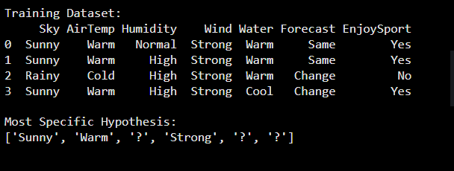

2. For a given set of training data examples stored in a .CSV file, implement and demonstrate the, Candidate-Elimination algorithm in python to output a description of the set of all hypotheses, consistent with the training examples
CODE:
# ============================================================
# EXPERIMENT: CANDIDATE-ELIMINATION ALGORITHM
# ============================================================
import pandas as pd
from itertools import product

# ------------------------------------------------------------
# STEP 1: Create Training Dataset and save it as CSV
# ------------------------------------------------------------
data = {
'Sky': ['Sunny', 'Sunny', 'Rainy', 'Sunny'],
'AirTemp': ['Warm', 'Warm', 'Cold', 'Warm'],
'Humidity': ['Normal', 'High', 'High', 'High'],
'Wind': ['Strong', 'Strong', 'Strong', 'Strong'],
'Water': ['Warm', 'Warm', 'Warm', 'Cool'],
'Forecast': ['Same', 'Same', 'Change', 'Change'],
'EnjoySport': ['Yes', 'Yes', 'No', 'Yes']
}
df = pd.DataFrame(data)
# Save dataset as CSV
df.to_csv('training_data.csv', index=False)
# Read CSV file
data = pd.read_csv('training_data.csv')

print("TRAINING DATASET")
print("=" * 70)
print(data.to_string(index=False))
# ------------------------------------------------------------
# STEP 2: Initialize Attributes
# ------------------------------------------------------------

attributes = list(data.columns[:-1])
target = data.columns[-1]

# Get possible values of every attribute
domains = {}

for attribute in attributes:
domains[attribute] = list(data[attribute].unique())

print("\nAttributes:")
print(attributes)

# ------------------------------------------------------------
# STEP 3: Functions
# ------------------------------------------------------------

# Check whether a hypothesis covers an example
def covers(h, example):

for i in range(len(h)):

# Ø means no example is covered
if h[i] == 'Ø':
return False
# ? accepts any value
if h[i] != '?' and h[i] != example[i]:
return False
return True
# Check whether h1 is more general than or equal to h2
def more_general_or_equal(h1, h2):
for a, b in zip(h1, h2):
if a == '?':
continue

if a == b:
continue
return False
return True
# Remove duplicate hypotheses
def remove_duplicates(hypotheses):

result = []

for h in hypotheses:
if h not in result:
result.append(h)

return result
# ------------------------------------------------------------
# STEP 4: Candidate-Elimination Algorithm
# ------------------------------------------------------------

# Most specific boundary
S = [('Ø',) * len(attributes)]
# Most general boundary
G = [('?',) * len(attributes)]
# Process every training example
for index, row in data.iterrows():

example = tuple(row[attributes])
label = row[target]
print("\n" + "-" * 70)
print("Example", index + 1)
print("Data :", example)
print("Class:", label)
# ========================================================
# POSITIVE EXAMPLE
# ========================================================

if label == 'Yes':

# Remove G hypotheses that do not cover positive example
G = [g for g in G if covers(g, example)
new_S = []
for s in S:
if covers(s, example):
new_S.append(s)

else:
# Generalize S minimally
h = list(s)
for i in range(len(attributes)):

if h[i] == 'Ø':
h[i] = example[i]

elif h[i] != example[i]:
h[i] = '?'
h = tuple(h)
# Keep h only if it is not more general than
# any hypothesis in G
valid = True

for g in G:
if not more_general_or_equal(g, h):
valid = False
break
if valid:
new_S.append(h)
S = remove_duplicates(new_S)

# Remove S hypotheses that are more general than
# another S hypothesis
final_S = []
for s in S:
keep = True
for s2 in S:

if s != s2 and more_general_or_equal(s, s2):
keep = False
break

if keep:
final_S.append(s)

S = final_S
# ========================================================
# NEGATIVE EXAMPLE
# ========================================================
else:

# Remove S hypotheses that cover negative example
S = [s for s in S if not covers(s, example)]
OUTPUT
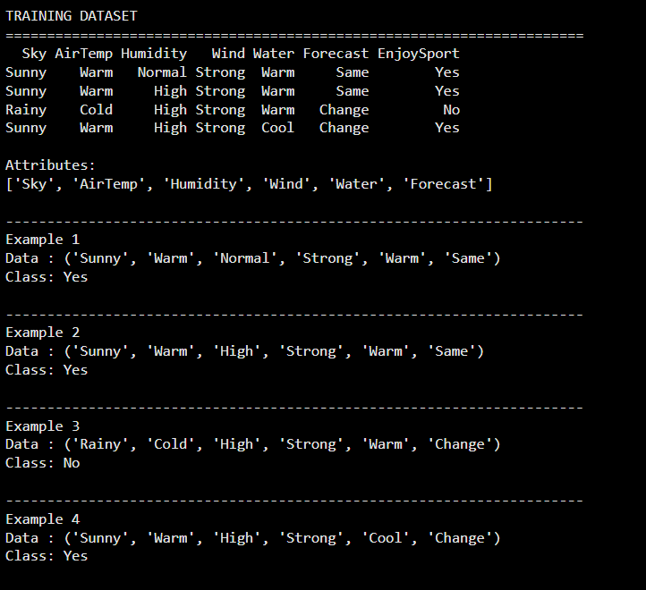

3. Demonstrate the working of the decision tree based ID3 algorithm. Use an appropriate data set, for building the decision tree and apply this knowledge to classify a new sample.
CODE:
# ============================================================
# EXPERIMENT: DECISION TREE USING ID3 ALGORITHM
# ============================================================
import pandas as pd
import math
from collections import Counter
from sklearn.tree import DecisionTreeClassifier, plot_tree
import matplotlib.pyplot as plt
# ------------------------------------------------------------
# STEP 1: Create Dataset
# ------------------------------------------------------------
data = {
'Outlook': [
'Sunny', 'Sunny', 'Overcast', 'Rain', 'Rain',
'Rain', 'Overcast', 'Sunny', 'Sunny', 'Rain',
'Sunny', 'Overcast', 'Overcast', 'Rain'
],

'Temperature': [
'Hot', 'Hot', 'Hot', 'Mild', 'Cool',
'Cool', 'Cool', 'Mild', 'Cool', 'Mild',
'Mild', 'Mild', 'Hot', 'Mild'
],

'Humidity': [
'High', 'High', 'High', 'High', 'Normal',
'Normal', 'Normal', 'High', 'Normal', 'Normal',
'Normal', 'High', 'Normal', 'High],

'Wind': [
'Weak', 'Strong', 'Weak', 'Weak', 'Weak',
'Strong', 'Strong', 'Weak', 'Weak', 'Weak',
'Strong', 'Strong', 'Weak', 'Strong'
],
'PlayTennis': [
'No', 'No', 'Yes', 'Yes', 'Yes',
'No', 'Yes', 'No', 'Yes', 'Yes',
'Yes', 'Yes', 'Yes', 'No'
]
}
df = pd.DataFrame(data)
print("TRAINING DATASET")
print("=" * 70)
print(df.to_string(index=False))
# ------------------------------------------------------------
# STEP 2: Entropy Function
# ------------------------------------------------------------
def entropy(target):
counts = Counter(target)
total = len(target)

result = 0

for count in counts.values():
probability = count / total
result -= probability * math.log2(probability)
return result

# ------------------------------------------------------------
# STEP 3: Information Gain Function
# ------------------------------------------------------------

def information_gain(data, attribute, target):

total_entropy = entropy(data[target])

weighted_entropy = 0

for value in data[attribute].unique():

subset = data[data[attribute] == value]

weighted_entropy += (
len(subset) / len(data)
) * entropy(subset[target])

return total_entropy - weighted_entropy
# ------------------------------------------------------------
# STEP 4: Calculate Information Gain
# ------------------------------------------------------------

print("\n" + "=" * 70)
print("INFORMATION GAIN")
print("=" * 70)

attributes = list(df.columns[:-1])

for attribute in attributes:

gain = information_gain(df, attribute, 'PlayTennis')

print(f"{attribute:15} : {gain:.4f}")

# ------------------------------------------------------------
# STEP 5: ID3 Decision Tree
# ------------------------------------------------------------

def id3(data, attributes, target):

# If all examples belong to one class
if len(data[target].unique()) == 1:
return data[target].iloc[0]
# If no attributes remain
if len(attributes) == 0:
return data[target].mode()[0]

# Find attribute with maximum information gain
gains = {}

for attribute in attributes:
gains[attribute] = information_gain(
data, attribute, target
)

best_attribute = max(gains, key=gains.get)

tree = {best_attribute: {}}

remaining_attributes = [
attribute for attribute in attributes
if attribute != best_attribute
]

# Create branches
for value in data[best_attribute].unique():

subset = data[data[best_attribute] == value]

if subset.empty:
tree[best_attribute][value] = data[target].mode()[0]

else:
tree[best_attribute][value] = id3(
subset,
remaining_attributes,
target
)
return tree
# Build tree
decision_tree = id3(
df,
attributes,
'PlayTennis'
)

print("\n" + "=" * 70)
print("ID3 DECISION TREE")
print("=" * 70)

print(decision_tree)
# ------------------------------------------------------------
# STEP 6: Classification Function
# ------------------------------------------------------------

def classify(tree, sample):

# If tree directly contains a class
if not isinstance(tree, dict):
return tree
attribute = next(iter(tree))

value = sample[attribute]

subtree = tree[attribute][value]

return classify(subtree, sample)
# ------------------------------------------------------------
# STEP 7: Classify a New Sample
# ------------------------------------------------------------

new_sample = {
'Outlook': 'Sunny',
'Temperature': 'Cool',
'Humidity': 'High',
'Wind': 'Strong'
}
prediction = classify(
decision_tree,
new_sample
)
print("\n" + "=" * 70)
print("CLASSIFICATION OF NEW SAMPLE")
print("=" * 70)
print("New Sample:")
print(new_sample)
print("\nPredicted Class:", prediction)
# ------------------------------------------------------------
# STEP 8: Visualize Decision Tree
# ------------------------------------------------------------
# Convert categorical data to numerical values
df_encoded = df.copy()
for column in df_encoded.columns:
df_encoded[column] = df_encoded[column].astype('category').cat.codes
X = df_encoded.drop('PlayTennis', axis=1)
y = df_encoded['PlayTennis']

# Train sklearn ID3-equivalent decision tree
model = DecisionTreeClassifier(
criterion='entropy',
random_state=42
)
model.fit(X, y)
plt.figure(figsize=(14, 8))
plot_tree(
model,
feature_names=X.columns,
class_names=['No', 'Yes'],
filled=True,
rounded=True
)
plt.title("Decision Tree using ID3 (Entropy)")
plt.show()

OUTPUT:
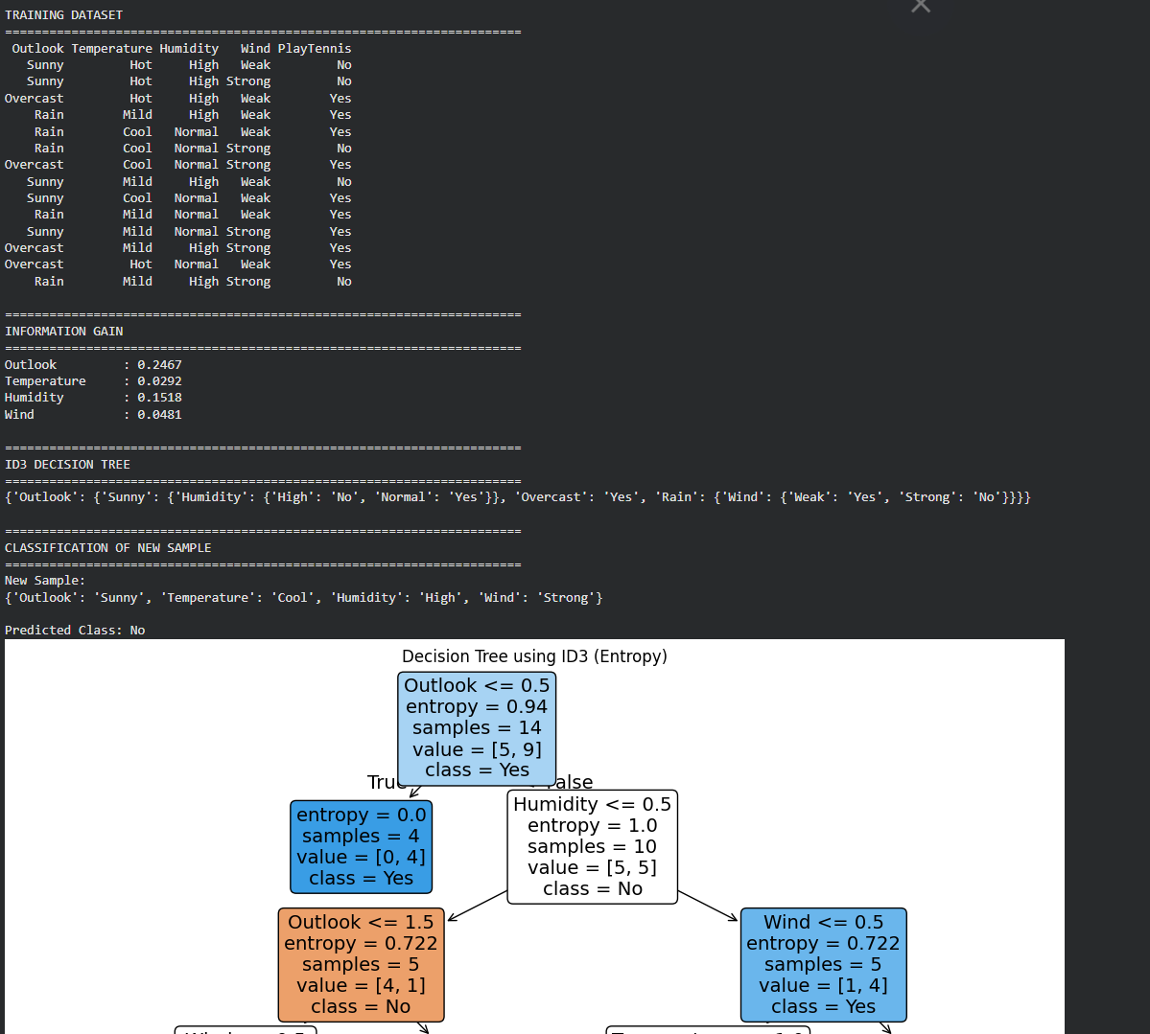

4. Build an Artificial Neural Network by implementing the Backpropagation algorithm and test the, same using appropriate data sets.

CODE:
# ============================================================
# EXPERIMENT: ARTIFICIAL NEURAL NETWORK USING BACKPROPAGATION
# ============================================================
import numpy as np
# ------------------------------------------------------------
# STEP 1: Training Dataset
# XOR Dataset
# ------------------------------------------------------------
X = np.array([
[0, 0],
[0, 1],
[1, 0],
[1, 1]
], dtype=float)
Y = np.array([
[0],
[1],
[1],
[0]
], dtype=float)
# ------------------------------------------------------------
# STEP 2: Initialize Network Parameters
# ------------------------------------------------------------

np.random.seed(42)

input_neurons = 2
hidden_neurons = 4
output_neurons = 1

# Weights
W1 = np.random.randn(input_neurons, hidden_neurons)
W2 = np.random.randn(hidden_neurons, output_neurons)

# Biases
b1 = np.zeros((1, hidden_neurons))
b2 = np.zeros((1, output_neurons))

# ------------------------------------------------------------
# STEP 3: Activation Function
# ------------------------------------------------------------

def sigmoid(x):
return 1 / (1 + np.exp(-x))

def sigmoid_derivative(x):
return x * (1 - x)

# ------------------------------------------------------------
# STEP 4: Backpropagation Training
# ------------------------------------------------------------

learning_rate = 0.5
epochs = 10000

for epoch in range(epochs):

# -------------------------
# Forward Propagation
# -------------------------

hidden_input = np.dot(X, W1) + b1
hidden_output = sigmoid(hidden_input)

output_input = np.dot(hidden_output, W2) + b2
output = sigmoid(output_input)
# -------------------------
# Calculate Error
# -------------------------

error = Y - output
# -------------------------
# Backpropagation
# -------------------------
output_delta = error * sigmoid_derivative(output)

hidden_error = np.dot(output_delta, W2.T)

hidden_delta = hidden_error * sigmoid_derivative(hidden_output)
# -------------------------
# Update Weights and Biases
# -------------------------

W2 += learning_rate * np.dot(hidden_output.T, output_delta)
b2 += learning_rate * np.sum(output_delta, axis=0, keepdims=True)

W1 += learning_rate * np.dot(X.T, hidden_delta)
b1 += learning_rate * np.sum(hidden_delta, axis=0, keepdims=True)

# ------------------------------------------------------------
# STEP 5: Test the Trained Neural Network
# ------------------------------------------------------------

hidden_input = np.dot(X, W1) + b1
hidden_output = sigmoid(hidden_input)
output_input = np.dot(hidden_output, W2) + b2
predicted_output = sigmoid(output_input)
# Convert probabilities into 0 or 1
predicted_class = (predicted_output >= 0.5).astype(int)
# ------------------------------------------------------------
# STEP 6: Display Results
# ------------------------------------------------------------

print("=" * 60)
print("ARTIFICIAL NEURAL NETWORK - BACKPROPAGATION")
print("=" * 60)

print("\nTraining Dataset:")
print("Input\tTarget")

for i in range(len(X)):
print(X[i].astype(int), "\t", Y[i].astype(int))
print("\n" + "-" * 60)
print("TEST RESULTS")
print("-" * 60)

print("Input\tTarget\tPredicted")

for i in range(len(X)):
print(
X[i].astype(int),
"\t",
int(Y[i][0]),
"\t",
int(predicted_class[i][0])
)
# ------------------------------------------------------------
# STEP 7: Calculate Accuracy
# ------------------------------------------------------------
accuracy = np.mean(predicted_class == Y) * 100

print("\nAccuracy:", accuracy, "%")

OUTPUT:
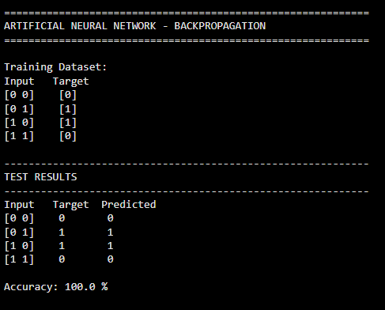

5. Write a program for Implementation of K-Nearest Neighbours (K-NN) in Python

CODE:
#
# EXPERIMENT: IMPLEMENTATION OF K-NEAREST NEIGHBOURS (K-NN)
#
import numpy as np
import pandas as pd
from sklearn.datasets import load_iris
from sklearn.model_selection import train_test_split
from sklearn.preprocessing import StandardScaler
from sklearn.neighbors import KNeighborsClassifier
from sklearn.metrics import accuracy_score, confusion_matrix
# ------------------------------------------------------------
# STEP 1: Load Dataset
# ------------------------------------------------------------
iris = load_iris()
X = iris.data
Y = iris.target
print("=" * 60)
print("IRIS DATASET")
print("=" * 60)

print("\nFeatures:")
print(iris.feature_names)

print("\nClasses:")
print(iris.target_names)

print("\nDataset Shape:", X.shape)

# ------------------------------------------------------------
# STEP 2: Split Dataset into Training and Testing Data
# ------------------------------------------------------------

X_train, X_test, Y_train, Y_test = train_test_split(
X,
Y,
test_size=0.2,
random_state=42)
print("\nTraining Samples:", len(X_train))
print("Testing Samples :", len(X_test))
# ------------------------------------------------------------
# STEP 3: Feature Scaling
# ------------------------------------------------------------

scaler = StandardScaler()

X_train = scaler.fit_transform(X_train)
X_test = scaler.transform(X_test)
# ------------------------------------------------------------
# STEP 4: Create K-NN Model
# ------------------------------------------------------------
K = 5
model = KNeighborsClassifier(n_neighbors=K)

# Train the model
model.fit(X_train, Y_train)
# ------------------------------------------------------------
# STEP 5: Predict Test Data
# -----------------------------------------------------------

Y_pred = model.predict(X_test)
# ------------------------------------------------------------
# STEP 6: Calculate Accuracy
# ------------------------------------------------------------
accuracy = accuracy_score(Y_test, Y_pred)

print("\n" + "=" * 60)
print("K-NN RESULTS")
print("=" * 60)

print("\nK value:", K)

print("Accuracy:", accuracy * 100, "%")

# ------------------------------------------------------------
# STEP 7: Display Predictions
# ------------------------------------------------------------

print("\nActual vs Predicted:")
print("-" * 40)

for actual, predicted in zip(Y_test, Y_pred):

print(
"Actual:",
iris.target_names[actual],
" | Predicted:",
iris.target_names[predicted]
)

# ------------------------------------------------------------
# STEP 8: Confusion Matrix
# ------------------------------------------------------------

cm = confusion_matrix(Y_test, Y_pred)

print("\nConfusion Matrix:")
print(cm)

# ------------------------------------------------------------
# STEP 9: Predict a New Sample
# ------------------------------------------------------------

# New flower:
# [Sepal Length, Sepal Width, Petal Length, Petal Width]

new_sample = np.array([
[5.1, 3.5, 1.4, 0.2]
])
# Scale the new sample
new_sample_scaled = scaler.transform(new_sample)

# Predict
prediction = model.predict(new_sample_scaled)
print("\n" + "=" * 60)
print("NEW SAMPLE CLASSIFICATION")
print("=" * 60)
print("\nNew Sample:", new_sample[0])
print(
"Predicted Class:",
iris.target_names[prediction[0]]
)

OUTPUT:

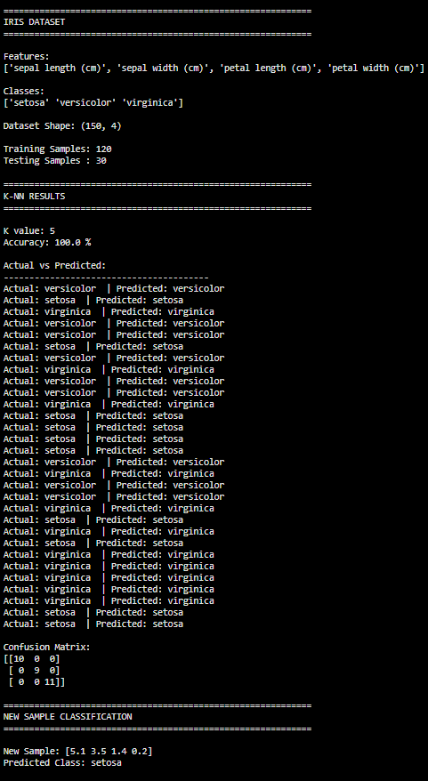

6. Write a program to implement Naïve Bayes algorithm in python and to display the results using confusion matrix and accuracy.
code:
# EXP 7: Naïve Bayes Algorithm
# Implement Naïve Bayes and display Confusion Matrix and Accuracy
# Import libraries
import numpy as np
import pandas as pd
import matplotlib.pyplot as plt
import seaborn as sns

from sklearn.datasets import load_iris
from sklearn.model_selection import train_test_split
from sklearn.naive_bayes import GaussianNB
from sklearn.metrics import confusion_matrix, accuracy_score, classification_report

# Load Iris dataset
iris = load_iris()
X = iris.data
y = iris.target

# Split dataset into training and testing sets
X_train, X_test, y_train, y_test = train_test_split(
X, y, test_size=0.30, random_state=42
)

# Create Naïve Bayes model
model = GaussianNB()

# Train the model
model.fit(X_train, y_train)

# Predict test data
y_pred = model.predict(X_test)

# Calculate accuracy
accuracy = accuracy_score(y_test, y_pred)

print("Actual Values:")
print(y_test)

print("\nPredicted Values:")
print(y_pred)

print("\nAccuracy:", accuracy)
print("Accuracy Percentage:", accuracy * 100, "%")

# Confusion Matrix
cm = confusion_matrix(y_test, y_pred)

print("\nConfusion Matrix:")
print(cm)

# Display Confusion Matrix
plt.figure(figsize=(6, 5))
sns.heatmap(
cm,
annot=True,
fmt="d",
cmap="Blues",
xticklabels=iris.target_names,
yticklabels=iris.target_names
)

plt.xlabel("Predicted Class")
plt.ylabel("Actual Class")
plt.title("Confusion Matrix - Naïve Bayes")
plt.show()

# Classification Report
print("\nClassification Report:")
print(classification_report(
y_test,
y_pred,
target_names=iris.target_names
))

output:
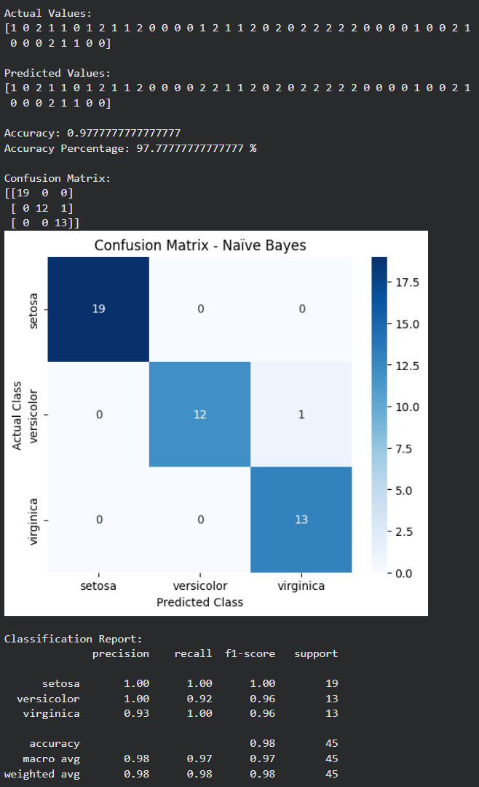

7. Write a program to implement Logistic Regression (LR) algorithm in python
code:
# EXP 7: Logistic Regression (LR)
# Implement Logistic Regression algorithm in Python

# Import required libraries
import numpy as np
import matplotlib.pyplot as plt
from sklearn.datasets import load_iris
from sklearn.model_selection import train_test_split
from sklearn.linear_model import LogisticRegression
from sklearn.metrics import accuracy_score, confusion_matrix, classification_report
import seaborn as sns

# Load Iris dataset
iris = load_iris()

X = iris.data
y = iris.target
# Split dataset into training and testing sets
X_train, X_test, y_train, y_test = train_test_split(
X, y, test_size=0.30, random_state=42
)
# Create Logistic Regression model
model = LogisticRegression(max_iter=200)
# Train the model
model.fit(X_train, y_train)
# Predict test data
y_pred = model.predict(X_test)
# Calculate accuracy
accuracy = accuracy_score(y_test, y_pred)
print("Actual Values:")
print(y_test)
print("\nPredicted Values:")
print(y_pred)
print("\nAccuracy:", accuracy)
print("Accuracy Percentage:", accuracy * 100, "%")
# Generate confusion matrix
cm = confusion_matrix(y_test, y_pred)

print("\nConfusion Matrix:")
print(cm)

# Display confusion matrix
plt.figure(figsize=(6, 5))
sns.heatmap(
cm,
annot=True,
fmt="d",
cmap="Blues",
xticklabels=iris.target_names,
yticklabels=iris.target_names
)
plt.xlabel("Predicted Class")
plt.ylabel("Actual Class")
plt.title("Confusion Matrix - Logistic Regression")
plt.show()

# Classification report
print("\nClassification Report:")
print(classification_report(
y_test,
y_pred,
target_names=iris.target_names
))
output:
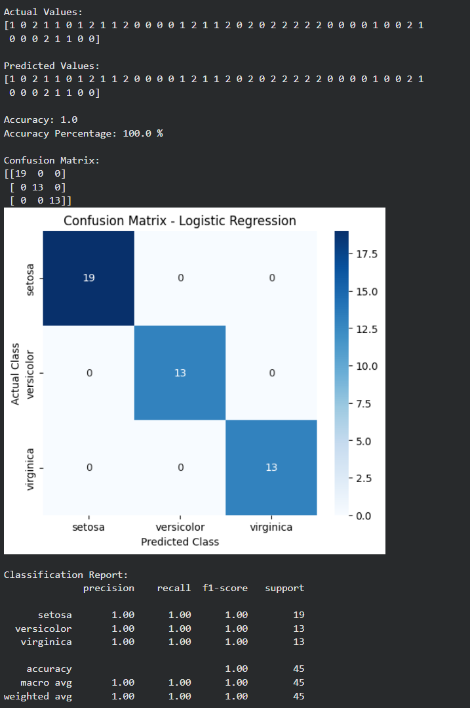

8. Write a program to implement Linear Regression (LR) algorithm in python
code:
# EXP 8: Linear Regression (LR)
# Implement Linear Regression algorithm in Python
# Import required libraries
import numpy as np
import matplotlib.pyplot as plt
from sklearn.model_selection import train_test_split
from sklearn.linear_model import LinearRegression
from sklearn.datasets import load_diabetes
from sklearn.metrics import mean_squared_error, r2_score
# Load dataset
data = load_diabetes()
X = data.data[:, [2]] # BMI feature
y = data.target
# Split dataset into training and testing sets
X_train, X_test, y_train, y_test = train_test_split(
X, y, test_size=0.30, random_state=42
)
# Create Linear Regression model
model = LinearRegression()
# Train the model
model.fit(X_train, y_train)
# Predict test data
y_pred = model.predict(X_test)
# Display coefficients
print("Slope (Coefficient):", model.coef_[0])
print("Intercept:", model.intercept_)
# Display actual and predicted values
print("\nActual Values:")
print(y_test)
print("\nPredicted Values:")
print("\nMean Squared Error:", mse)
print("R2 Score:", r2)
# Plot regression line
plt.figure(figsize=(8, 5))
plt.scatter(X_test, y_test, label="Actual Values")
plt.plot(X_test, y_pred, linewidth=2, label="Regression Line")
plt.xlabel("BMI")
plt.ylabel("Disease Progression")
plt.title("Linear Regression")
plt.legend()
plt.show()
output:
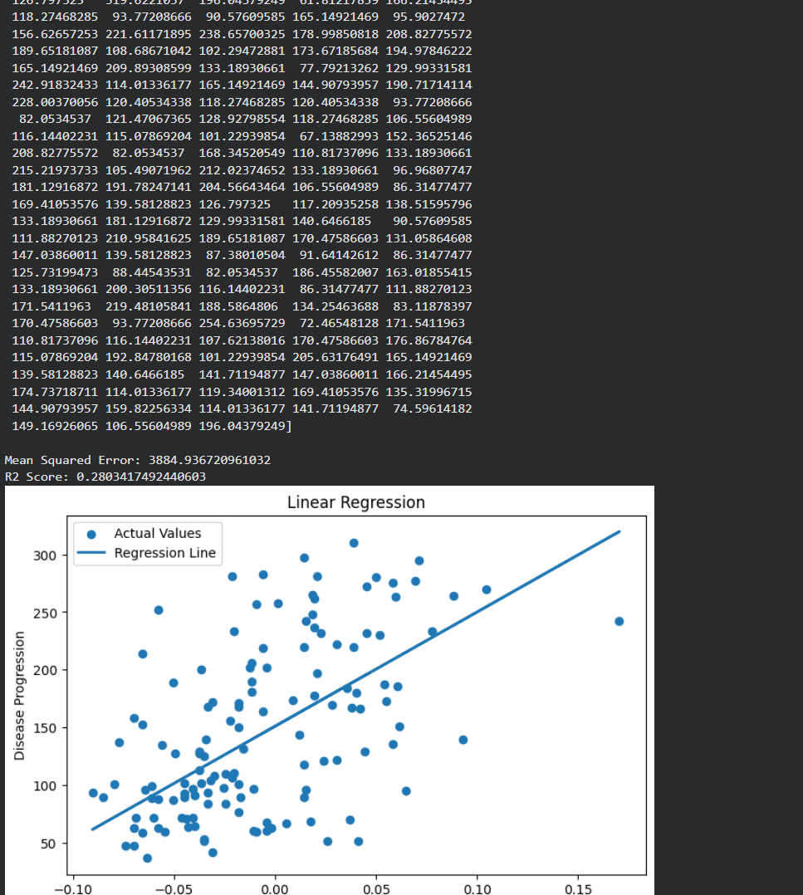

9. Compare Linear and Polynomial Regression using Python
code:
# EXP 9: Comparison of Linear and Polynomial Regression
# Import required libraries
import numpy as np
import matplotlib.pyplot as plt
from sklearn.model_selection import train_test_split
from sklearn.linear_model import LinearRegression
from sklearn.preprocessing import PolynomialFeatures
from sklearn.metrics import mean_squared_error, r2_score

# Create sample dataset
np.random.seed(42)

X = np.linspace(0, 10, 100).reshape(-1, 1)
y = 2 * X.ravel() + 3 + 5 * np.sin(X.ravel()) + np.random.normal(0, 2, 100)

# Split dataset
X_train, X_test, y_train, y_test = train_test_split(
X, y, test_size=0.30, random_state=42
)

# ---------------- Linear Regression ----------------
linear_model = LinearRegression()
linear_model.fit(X_train, y_train)

y_pred_linear = linear_model.predict(X_test)

linear_mse = mean_squared_error(y_test, y_pred_linear)
linear_r2 = r2_score(y_test, y_pred_linear)

# ---------------- Polynomial Regression ----------------
poly = PolynomialFeatures(degree=3)
X_train_poly = poly.fit_transform(X_train)
X_test_poly = poly.transform(X_test)

poly_model = LinearRegression()
poly_model.fit(X_train_poly, y_train)

y_pred_poly = poly_model.predict(X_test_poly)

poly_mse = mean_squared_error(y_test, y_pred_poly)
poly_r2 = r2_score(y_test, y_pred_poly)

# Display results
print("LINEAR REGRESSION")
print("Mean Squared Error:", linear_mse)
print("R2 Score:", linear_r2)

print("\nPOLYNOMIAL REGRESSION")
print("Mean Squared Error:", poly_mse)
print("R2 Score:", poly_r2)

# Compare models
print("\nCOMPARISON")
if poly_r2 > linear_r2:
print("Polynomial Regression performs better.")
else:
print("Linear Regression performs better.")
# Plot results
plt.plot(X_curve, linear_curve, linewidth=2, label="Linear Regression")
plt.plot(X_curve, poly_curve, linewidth=2, label="Polynomial Regression")
plt.xlabel("X")
plt.ylabel("Y")
plt.title("Linear vs Polynomial Regression")
plt.legend()
plt.grid(True)
plt.show()

output:
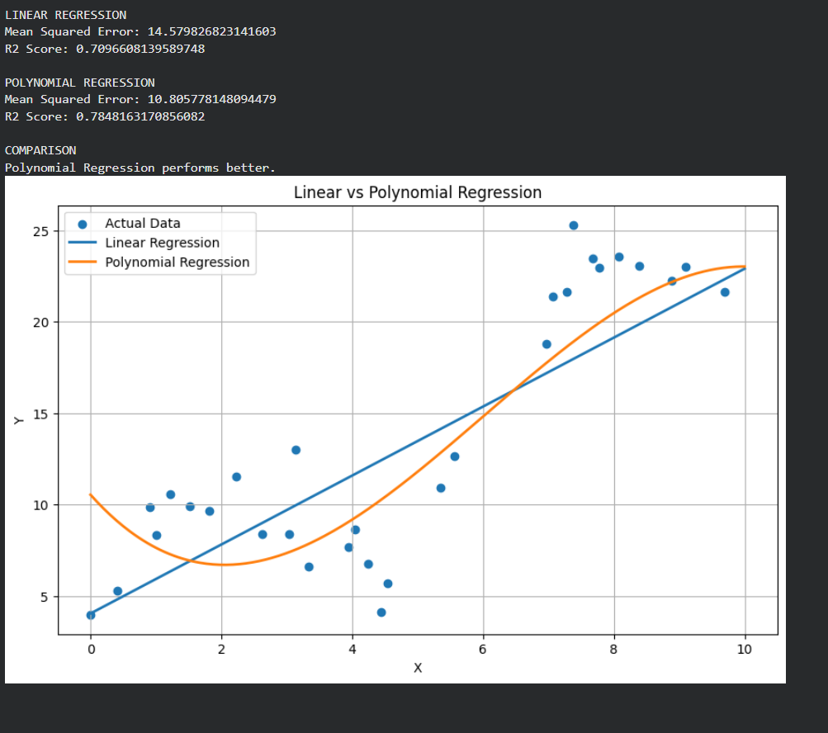

10. Write a Python Program to Implement Expectation & Maximization Algorithm
code:
# EXP 10: Expectation-Maximization (EM) Algorithm
# Implement EM algorithm using Gaussian Mixture Model
import numpy as np
import matplotlib.pyplot as plt
from sklearn.mixture import GaussianMixture
# Generate sample data
np.random.seed(42)
X1 = np.random.normal(2, 0.8, 100)
X2 = np.random.normal(7, 1.0, 100)
X = np.concatenate([X1, X2]).reshape(-1, 1)
# Create Gaussian Mixture Model
em_model = GaussianMixture(
n_components=2,
random_state=42
)

# Train the model using Expectation-Maximization
em_model.fit(X)
# Predict cluster labels
labels = em_model.predict(X)
# Display parameters
print("Means of the clusters:")
print(em_model.means_)
print("\nCovariances of the clusters:")
print(em_model.covariances_)
print("\nMixing weights:")
print(em_model.weights_)

# Display cluster assignments
print("\nCluster Labels:")
print(labels)
# Plot the clusters
plt.figure(figsize=(8, 5))
plt.scatter(
X[labels == 0],
np.zeros_like(X[labels == 0]),
label="Cluster 1"
)
plt.scatter(
X[labels == 1],
np.zeros_like(X[labels == 1]),
label="Cluster 2"
)
plt.xlabel("Data Values")
plt.ylabel("Cluster")
plt.title("Expectation-Maximization Algorithm")
plt.legend()
plt.show()
output:
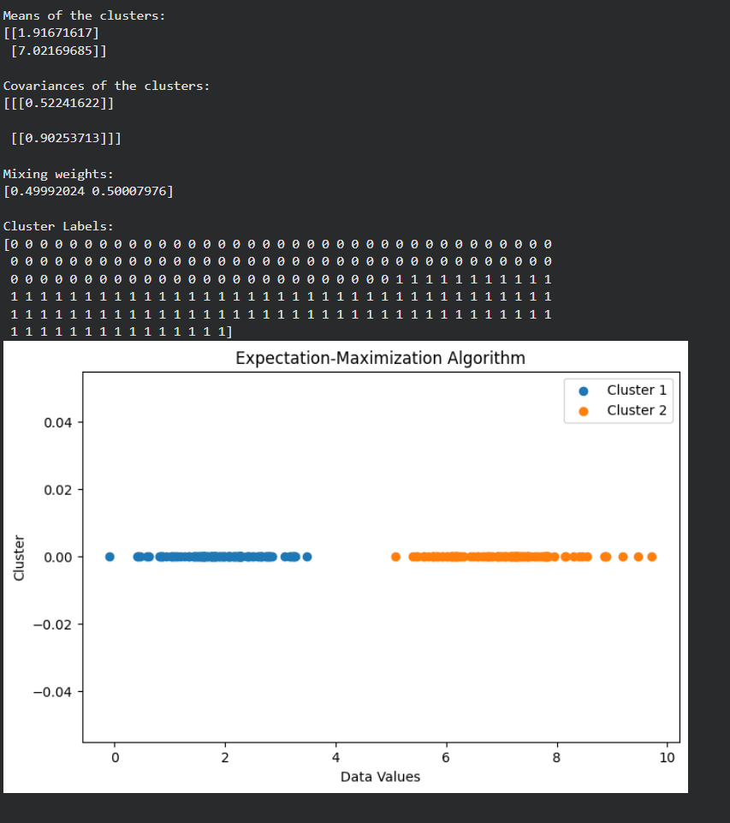
11. Write a program for the task of Credit Score Classification
code:
# EXP 11: Credit Score Classification
# Python program to classify credit scores using Random Forest
import numpy as np
import pandas as pd
import matplotlib.pyplot as plt
import seaborn as sns
from sklearn.model_selection import train_test_split
from sklearn.ensemble import RandomForestClassifier
from sklearn.metrics import accuracy_score, confusion_matrix, classification_report

# Create sample credit score dataset
np.random.seed(42)
data = {
"Age": np.random.randint(18, 65, 300),
"Annual_Income": np.random.randint(20000, 120000, 300),
"Loan_Amount": np.random.randint(5000, 100000, 300),
"Credit_Utilization": np.random.uniform(0.1, 0.9, 300),
"Payment_History": np.random.randint(1, 11, 300)
}
df = pd.DataFrame(data)
# Create credit score classes
def classify_credit(row):
score = (
row["Payment_History"] * 50
+ row["Annual_Income"] / 10000
- row["Loan_Amount"] / 20000
- row["Credit_Utilization"] * 20
)

if score >= 400:
return "Good"
elif score >= 300:
return "Average"
else:
return "Poor"
df["Credit_Score"] = df.apply(classify_credit, axis=1)
# Features and target
X = df.drop("Credit_Score", axis=1)
y = df["Credit_Score"]

# Split dataset
X_train, X_test, y_train, y_test = train_test_split(
X, y, test_size=0.30, random_state=42, stratify=y
)
# Create Random Forest classifier
model = RandomForestClassifier(
n_estimators=100,
random_state=42
)

# Train model
model.fit(X_train, y_train)
# Predict
y_pred = model.predict(X_test)
# Accuracy
accuracy = accuracy_score(y_test, y_pred)
print("Actual Values:")
print(y_test.values)
print("\nPredicted Values:")
print(y_pred)
print("\nAccuracy:", accuracy)
print("Accuracy Percentage:", accuracy * 100, "%")

# Confusion Matrix
cm = confusion_matrix(
y_test,
y_pred,
labels=["Poor", "Average", "Good"]
)
print("\nConfusion Matrix:")
print(cm)
# Display confusion matrix
plt.figure(figsize=(6, 5))
sns.heatmap(
cm,
annot=True,
fmt="d",
cmap="Blues",
xticklabels=["Poor", "Average", "Good"],
yticklabels=["Poor", "Average", "Good"]
)

plt.xlabel("Predicted Class")
plt.ylabel("Actual Class")
plt.title("Credit Score Classification")
plt.show()

# Classification report
print("\nClassification Report:")
print(
classification_report(
y_test,
y_pred,
labels=["Poor", "Average", "Good"]
)
)
output:
